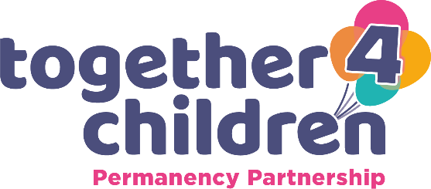
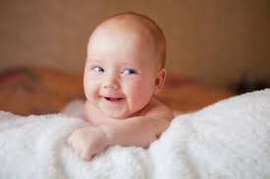

Childs Name

The things people love about me
Information…………………………………………………………………………………………………………………………………………………………………………….

Family and Social Relationships
Information ………………………………………………………………………………………………………………………………………………………………………………..

Health and Development
Information …………………………………………………………………………………………………………………………………………………………………………………..

Family Sought for ….
Information ………………………………………………………………………………………………………………………………………………………………………………….

