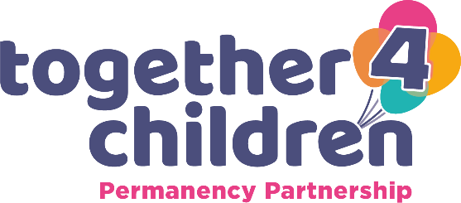

MATCHING CERTIFICATE

ONLY the adoption agency responsible for conducting the adoption of the child in
question can fill in this form.

Details of prospective Adoptive Parent(s)
Name:
Address:

I confirm that the person(s) named above has been approved for adoption and matched with a child by our agency Together4Children
They were notified of this on:
It is expected that the child will be placed with them on:
The child was placed with them on:
Agency Name and Address
Together4Children
Permanency Partnership
Central Permanency Hub
2 Staffordshire Place
Tipping Street
Stafford
ST16 2DH
Tel: 0300 111 8044
Email: together4children@staffordshire.gov.uk

This adoption agency is approved under the Adoption and Children Act 2002.
Name | Title
Signature | Date

